

RECRUITMENT TOOLKIT
PART A: Pre - Interview
- Applications
- Special Categories of Applicants
- Young People
- Disabled People
- Methods of Applying
- Resume
- Screening Applicants
- Applicant Assessment Form
- Controlling Applications
- Response Analysis
FOR MORE INFORMATION CONTACT THE
AAAA HR HOTLINE: 1300 735 306
APPLICATIONS

SPECIAL CATEGORIES OF APPLICANTS

Summary:
There are 2 main categories of Applicants that further consideration should be considered. These are Young People and Disabled People.

Young People
- Most adolescents will have come directly from school where they have been accustomed to a sheltered, structured environment where standards of behaviour and performance have been laid down in quite rigid forms with feedback provided by teachers on a regular basis.
- In the majority of cases, their previous work experience will have been limited to work experience programs organised in conjunction with the school and/or part-time and casual jobs, the latter usually of a rather menial nature
- Interviewers need to have a sympathetic understanding of an adolescent's environment and need to think through the issues which will be of most concern to candidates in this age group.

Advertisements and applications:
- Timing of recruitment campaigns can be important. For example, school holidays tend to be a more convenient time for students and periods during or just prior to exams should obviously be avoided.
- Job advertisements should clearly indicate minimum standards of qualifications, education levels, etc. In many cases it may also be wise to specify maximum standards.
- It may be useful to form liaisons with careers advisors at local schools, through providing written information, accepting invitations to visit the schools and by means of student work experience programs.
- Large organisations may find it worthwhile to use a different employment application form for school leavers. Such a form might have provision for more detail on school subjects and results, school reports/references, the applicant's interests and hobbies, and reasons why the applicant has applied to this particular organisation.
- As younger people tend to be more internet- and technology-savvy than their elders, it is obviously advisable to make extensive use of online recruitment and information-providing techniques.

Disabled People
- The types of employment aids required by each disability will vary, with some requiring very little, if any, assistance. Advice on helpful ways to deal with each group is widely available.
- Various studies of disabled employees indicate that in terms of job performance, labour turnover, absenteeism, safety on the job and relationships with work peers, disabled employees in general perform as well as other employees and may in fact be superior in some areas. While adjustments may need to be made to the workplace and work equipment in some cases, this can be offset in the longer term by superior job performance and, in any case, financial assistance is often available to organisations to make changes.
- The success of a disabled person in the workplace will depend very much on his/her outlook and ability to adjust to and operate effectively in a new environment, as well as the reactions of other workers. Hence the importance placed on prior training and careful placement.
- With an intellectually disabled person, the main drawbacks are greater time and less ability to learn new things, less insight and judgment, and shorter attention and memory spans. Therefore, the induction period and program will be longer and more tailored to the particular needs of the individual.
- Like all other applicants, disabled job applicants should have the opportunity to demonstrate their ability to perform the job and be assessed on the basis of job-related criteria.
- Note that equal opportunity legislation makes it unlawful to discriminate against disabled people in employment situations.

Methods of Applying | Description
In person | - Applying in person is a simple and efficient method for recruiting low-skilled, unskilled and trades staff  - It is suitable when large numbers of recruits are sought and are needed to start immediately  - Where neat personal appearance is an important requirement of the job, for example in the retail and hospitality industries, applications in person are commonly sought  - It is also the main method for handling internal applications, where the employer already knows the applicant and has detailed records of his/her employment history.
Telephone applications | - Telephone applications are appropriate for recruiting low-skilled, unskilled, trade and clerical staff.  - For Para-professional and professional staff, the phone call is used as a means of providing further information about the position, how to apply for it and in many instances (e.g. with overseas roles) the first stage of screening for a role.  - Interviews may be arranged without the need for written applications.  - A telephone conversation can serve as an initial screening device, particularly if the employer, or recruitment consultant, structures the conversation.  - Filter questions can be used effectively to ensure unsuitable candidates do not reach the interview stage with the attendant waste of time and money, and frustration.  - Filter questions should be based on the person specification and provide for an "informal" interview.
Written applications | - Unless it is an unsolicited approach for employment, most written applications usually involve an application/"cover" letter that addresses the desired criteria in an advertisement and a résumé (or curriculum vitae "CV"). The cover letter should aim to "market" the applicant's skills and experience.  - Many organisations (e.g. in the public sector) will require a form of theirs to be completed and submitted online with the résumé, or the content from the resume to be integrated into the form and submitted. Alternatively, the form may be downloadable by applicants to complete and email to a general recruitment email address at the organisation. Job recruitment boards are now a popular way of applying for a role with a cover letter and résumé, Thousands of jobs are posted every year via websites such as SEEKS and MyCareer.
METHODS OF APPLYING

Summary:
The job advertisement needs to specify clearly the method of applying for the job. It will depend on the level of the job, its degree of importance to the company, and the number of jobs available.

RESUME

Summary:
Résumés allow the applicant a free-form approach to their application. It’s important to
- They should contain the basic elements of application forms. These elements are normally supplemented by the applicant with further details of education, qualifications and experience. Personal interests and experiences such as hobbies and travel may be included. Some résumés include a photograph of the applicant.
- Résumés may also provide glimpses of the personality of the applicant, and they may include career aspirations, mission statements and personal goals. The presentation of the information and the amount of detail provided may also reveal aspects of the applicant's personality. They may also include unnecessary detail and embellishment.
- Résumés should be accompanied by a letter of application as the résumé is essentially a summary of relevant employment information.
- It is important to note that the information contained in a résumé is volunteered by the applicant and the level of personal detail is entirely at his/her discretion. The employer cannot be responsible for any breaches of privacy or anti-discrimination requirements due to receiving unsolicited details.
CHECKS TO HELP IDENTIFY POSSIBLE MISREPRESENTATIONS ON RESUMES |  | √
- Check for conflicting details, such as overlapping dates.
- Check for gaps in dates. Omissions may be due to a desire to cover up something, but note that they may also be concealed by ``overseas trips'' and ``self- employment''.
- Note the order in which the résumé presents information. Generally, applicants wish to emphasise the information which appears first.
- Providing excessive detail may be an attempt to draw attention away from key areas.
- When verifying references, confirm that the ``employer'' is a genuine one (eg not a relative or bogus company).
- Mail something to the applicant, such as a holding letter, to verify that the address provided is genuine.

Identifying misleading résumé contents
Misrepresentations by job applicants in their written résumés may take various forms, including lies, omissions, exaggerations and creative wording (for example, of previous job titles). The scope of problems ranges from minor omissions or embellishments to outright fraud. The problem appears to be most common at middle and upper management levels.
SCREENING APPLICANTS

Summary:
Once applications have been received, by one of the various means discussed, it is necessary to decide which ones to interview.

- For lower level jobs, applicants may be requested to complete application forms and the decision regarding which ones to interview is made by using the form as a screening device.

- If applicants have telephoned, the recruiting officer may discuss the position over the phone and call in those applicants who seem suitable. Where written or emailed applications for the position were required, the recruiting officer should study these and assess the potential applicants' letters in a similar way to the completed application form.

- There is no definite number of applicants that should be interviewed. The decision will depend on the number of applicants, quality of their applications, the number and type of jobs available and sometimes the amount of time available.

- Calling in a large number of applicants who appear to be suitable has the advantage of allowing the recruiter to assess many of the qualities required which cannot be evaluated from the application form, particularly if personal qualities are important for the position. Following these initial interviews, a ``short list'' of the most suitable applicants could be prepared for study by the head of the department requesting the employee.

- On the other hand, if there are few applications and they appear to be of high quality, all of them may be interviewed. Whatever the situation, if none of the applicants appear to go close to matching the person specification of the job, the interviewer should look for those applicants who have most of the qualities required and who could be trained by the organisation in the other areas in which they are presently lacking. The initial selection should be based around the essential requirements of the position.

Unsuitable Applicants
- Applicants who lack the qualifications or work experience necessary to perform the job should be eliminated during this ``screening'' process and not interviewed. To interview someone who is obviously unsuitable for the position is both time-wasting and inconvenient for the applicant as well as the employer.

- No applicant should be ruled out on personal prejudices although it may be necessary to consider personal preferences where work in small cohesive groups is involved.

- Applicants eliminated at this stage should be notified, preferably with some tactful explanation of why they were unsuitable. The time of notification can vary — some companies prefer to do it as soon as the person is eliminated; others wait until the final selection is made and then advise all unsuccessful applicants. The second method can be better, for if the employer fails to obtain anyone from the short list of applicants, he/she may wish to recall some of the people originally rejected and can then do so without embarrassment to either party. For an example of a suitable letter, see
APPLICANT ASSESSMENT FORM

Summary:
A simple form, such as the following example, can be used to assist the short-listing process, by comparing the selection criteria with the information supplied so far by each applicant. This form also tracks the follow-up action the recruiter may decide to take.
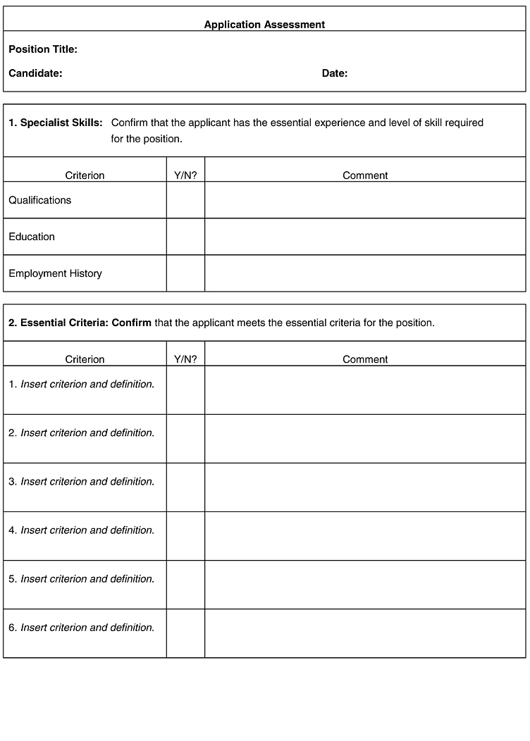

CONTROLLING APPLICATIONS

Summary:
When there are a large number of applications it may be useful to draw up a control sheet for the position, such as the one shown below. The sheet could also serve as the”short list''.
Note that software and web-related products are now available which can be used to track the status of applications.
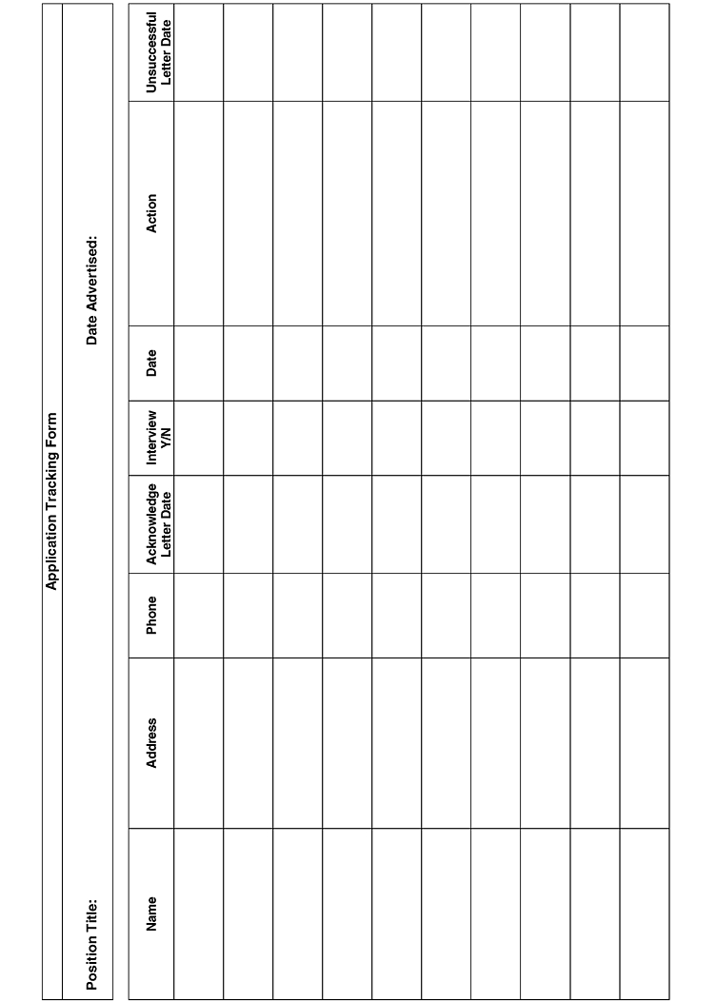

RESPONSE ANALYSIS
Summary:
Advertising will only be effective if some form of cost/benefit analysis is maintained and levels of response are continually monitored. Statistics should be kept as to number of replies, number of interviews given, from which source these were obtained and from which one the position was filled.
Over time, it should be possible to identify which types of advertisement and advertising media produce the best response for each type of vacancy and which ones produce the best applicants. It will also serve as a guide to improving future advertisements and ensure that only the successful media are used.
Without some form of analysis and control, advertising may become costly and wasteful, without guaranteeing suitable applicants. However, the ultimate test is the success of the new employee and the length of time he or she stays with the organisation.
A response analysis table could be drawn up like this:
Response analysis table
Position Advertised:
Medium where advertisement was placed and the frequency of advertisement | No of replies | No of Interviews | Position filled  Yes/No

