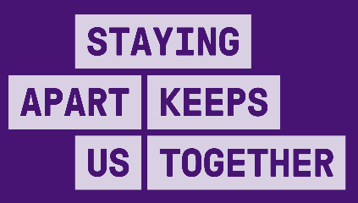
INDUSTRY RESTRICTION LEVELS
Common requirements across all workplaces
COMMON REQUIREMENTS | ACTIONS ACROSS ALL LEVELS | CLOSED | HEAVILY RESTRICTED | RESTRICTED | OPEN WITH A COVIDSAFE PLAN
ENSURE PHYSICAL DISTANCING | - Staff and visitors must be 1.5m apart at all times  - Density quotient applied to share spaces (e.g. workspace, tearooms)  - Display signs showing patron limits at the entrance to enclosed areas where limits apply  - Use floor markings to provide minimum physical distancing guides  - Minimise the build-up of people waiting to enter and exit the workplace  - Provide training to staff on physical distancing expectations while working and socialising (including during lunch breaks) | - No people on site except for emergency maintenance and repairs | - Staff can only attend work if permitted. Staff in permitted work premises must work from home, if they can  - Apply density quotient  - Reduce staff levels  - Limit number of patrons  - No carpooling to work | - Staff should work from home wherever possible  - Apply density quotient  - Some sectors allowed to lessen the reduction in staff levels  - Some sectors allowed to lessen the reduction in patrons  - No carpooling to work | - Staff should work from home wherever possible (to be relaxed over time)  - Apply density quotient for some settings (could be reduced over time)  - Ensure staff follow current public health directions when carpooling
WEAR A MASK | - All staff to wear a mask as per current directions  - Provide training/guidance on how to use PPE  - Install screens or barriers |  | - Ensure the proper use of masks in the workplace  - For some sectors, additional PPE requirements apply  - Ensure adequate PPE training and supply
PRACTISE GOOD HYGIENE | - Frequent and regular cleaning and disinfection of shared spaces  - Make soap and hand sanitiser available for all staff and customers throughout the workplace  - Replace high-touch communal items with hygienic alternatives  - Display a cleaning log in shared spaces |  | - Auditing of cleaning schedules | - Auditing of cleaning schedules
KEEP RECORDS AND ACT QUICKLY IF STAFF BECOME UNWELL | - Support staff to stay home and get tested even if they only have mild symptoms  - Have a plan to manage cases, notify others and potentially close down if there are coronavirus (COVID-19) cases  - Keep records of all people who enter the workplace for contact tracing  - Temperature checking |  | - Ask staff to declare in writing or electronically before each shift that they are free of symptoms, have not been in contact with a confirmed case and have not been directed to isolate | - Ask staff to declare verbally before each shift that they are free of symptoms
AVOID INTERACTIONS IN ENCLOSED SPACES | - Move as much activity outside as possible, including serving customers, meetings, kitchens, tearooms and lunchbreaks  - Enhance airflow by opening windows and doors  - Do not recirculate air
CREATE WORKFORCE BUBBLES | - Keep groups of staff rostered on the same shifts for a given geographic area/site  - No overlap in shift changes |  | - Ensure that staff members are not working across other work sites (exceptions apply) | - Limit number of staff members working across other work sites

Bold – mandatory under public health direction*
Not bold – recommended but not mandated
*Subject to final development of directions by Chief Health Officer

