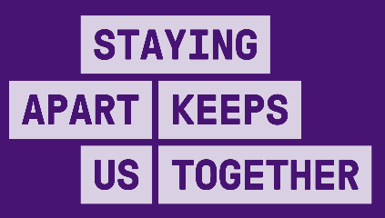
INDUSTRY RESTRICTION LEVELS
Manufacturing (excludes meat and seafood processing)

INDUSTRY SPECIFIC REQUIREMENTS | ACTIONS ACROSS ALL LEVELS | CLOSED | HEAVILY RESTRICTED  Current - Melbourne | RESTRICTED | OPEN WITH A COVIDSAFE PLAN
ENSURE PHYSICAL DISTANCING | - Staff and visitors must be 1.5m apart at all times  - Density quotient applied to shared spaces (e.g. workspace, tearooms)  - Use floor markings to provide minimum physical distancing guides  - Minimise the build-up of people waiting to enter and exit the workplace  - Provide all staff with mandatory COVIDSafe Training | - No people on site except for emergency maintenance and repairs | - Staff who can work from home must work from home  - Manufacturers can only operate if they are on the Permitted Work Premises list, or are supplying a permitted work premises  - Carpooling restricted as per public health directions | - Manufacturing that was closed in Heavily Restricted phase can operate at a maximum of 90% of normal daily worker level  - Staff who can work from home, should work from home  - Carpooling restricted as per public health directions | - Staff should work from home wherever possible (to be relaxed over time)
WEAR A FACE COVERING | - All staff to wear face coverings as per current directions  - Provide training/guidance on how to use PPE
PRACTISE GOOD HYGIENE | - Frequent and regular cleaning and disinfection of shared spaces  - Make soap and hand sanitiser available for all staff and customers throughout the workplace  - Replace high-touch communal items with hygienic alternatives  - Display a cleaning log in shared spaces |  | - Auditing of cleaning log | - Auditing of cleaning log
KEEP RECORDS AND ACT QUICKLY IF STAFF BECOME UNWELL | - Support staff to stay home and get tested even if they only have mild symptoms  - Have a plan to manage cases, notify others and potentially close down if there are positive coronavirus (COVID-19) cases  - Keep records of all people who enter a worksite for contact tracing  - Encourage temperature checking of all staff at the beginning of shifts |  | - Ask staff to declare in writing or electronically before each shift that are free of symptoms, have not been in contact with a confirmed case and have not been directed to isolate | - Ask staff to declare verbally before each shift that are free of symptoms
AVOID INTERACTIONS IN ENCLOSED SPACES | - Move as much activity outside as possible, including serving customers, meetings, kitchens, tearooms and lunchbreaks  - Open doors and windows wherever possible  - Do not recirculate air
CREATE WORKFORCE BUBBLES | - Should minimise number of staff members working across other work sites  - Keep groups of staff rostered on the same shifts/areas within a site  - No overlap in shift changes (where applicable)

Bold – mandatory under public health direction*
Not bold – recommended but not mandated
*Subject to final development of directions by Chief Health Officer

